Installation of Vinda
Here follows a detailed description on how to install Vinda. Below is a list of known issues (not so many so far…). If your issue is not described, pls. inform about the problem. The installation is in two parts: (1) running the setup program that will copy the relevant files to your file system, and (2) activation in Excel.

Installation and activation
Save the setup program on your computer and it is recommended to run it as an administrator | 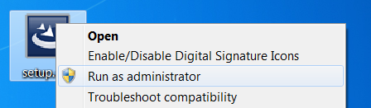
A series of screens are shown, just press Next > to all of them.  Vinda will now install files on your computer, and you can optionally view the readme file. Hit Finish when done. | 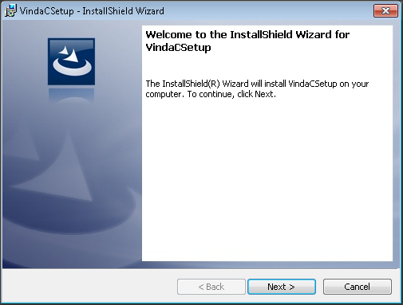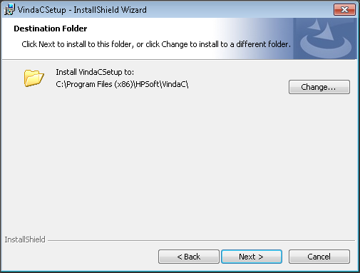  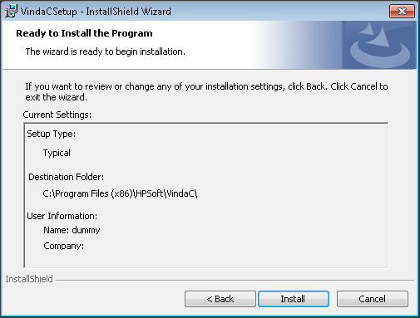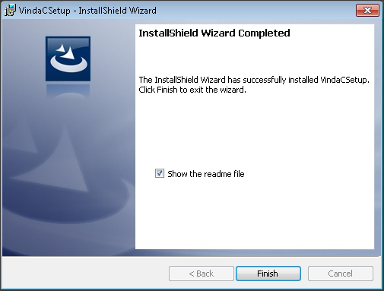
The next task is to activate Vinda in Excel. Open Excel and select File or the Office logo  in Office 2007, and then select Add-Ins, Manage: Excel Add-ins and click Go… | 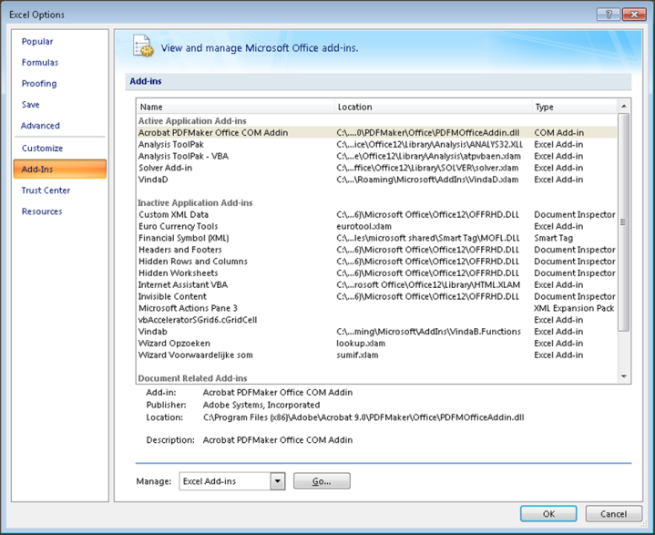
A selection of Add-Ins should be displayed, select VindaD and the Solver Add-in should also be selected (used for fitting). Press OK when done.  If an error comes up where Excel does not find files, see Note 1 below. | 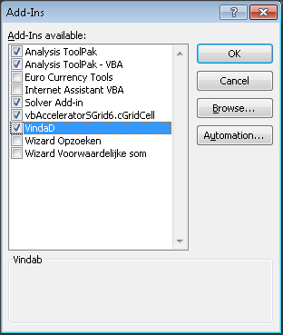
In Excel, a new tab, called VindaD should now be on the ribbon. | 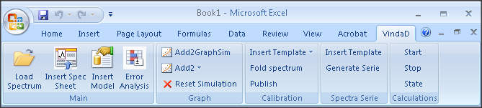
It is recommended to make a quick test of the installation. Select Insert Spec Sheet on the VindaD tab, thereafter go to e.g. the J column of the worksheet and select Insert Model from the VindaD tab. Select any model, and make sure that numbers are displayed in column K at row >30. If so, Vinda is correctly installed. | 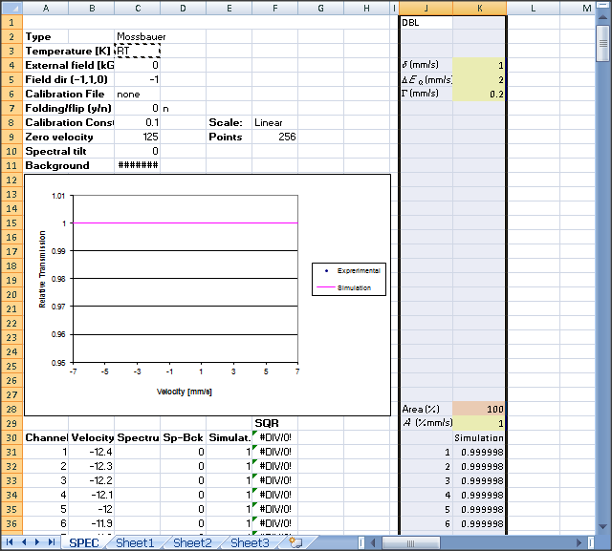

Known issues
Note | Description | How to solve
1 | Excel brings up an message that the files were not found, even though inspection shows that the files are there. | Re-install Excel. This error has been found to have roots in incorrect installation

